WORKING WITH RESOURCE T AGS

**Lab Details**

1. In this lab we will walk through the steps on how to set tags on resources.

**Introduction**

**What is a Virtual Machine?**

* A virtual machine (VM) is a virtual environment that functions as a virtual computer system with its own CPU, memory, network interface, and storage, created on a physical hardware system (located off- or on-premises).
* VMs allow multiple different operating systems to run simultaneously on a single computer
* A VM provides an environment that is isolated from the rest of a system, so whatever is running inside a VM won’t interfere with anything else running on the host hardware.

**What is a tag?**

* You apply tags to your Azure resources, resource groups, and subscriptions to logically organize them into a taxonomy.
* Each tag consists of a name and a value pair. For example, you can apply the name Environment and the value Production to all the resources in production.

**Architecture Diagram**

**Task Details**

1. Sign in to Azure Portal
2. Create a virtual machine
3. Create tags
4. Validation Test
5. Delete the resources

# **Lab Steps**

## **Task 1: Sign in to Azure Portal**

1. Go to the Azure portal by clicking on the **Open console** button or by using URL [https://portal.azure.com](https://portal.azure.com/).
   * **Note**: It is recommended to use incognito mode to avoid Azure portal cache related issues.
2. If it automatically logs into any other azure account, please logout of it and clear cache.
3. Sign in with your given username and password on Azure portal.

1. If login is not working. Click on the **End Lab** and start the lab again.

## **Task 2: Create a virtual machine**

1. From the Azure portal menu click on **virtual machines**.

1. On the virtual machine page click on **+create**, select **+ Create a Virtual machine** and enter the following values in the **Basics** tab:

* New Resource group : RG1
* Virtual Machine Name : Enter ***resizeVM***
* Region : Select **East US**
* Image : Select **Windows Server 2016 Datacenter - Gen2**
* Azure Spot instance : Leave the default of unchecked.
* Size : Click on **see all sizes** then select **B1s** and then **click on select**
* Username : Enter a username
* Password : Enter a password
* Confirm password : Re-enter **password**
* Public inbound ports : Leave default

1. Then select the **Disks** tab and in the **OS disk type**, select **Standard SSD**.

1. Click on **Review + create**and then **Create**. After a few minutes your deployment will be completed.

## **Task 3: Creating tags**

1. In the **Azure Portal Menu** click on **Resource Groups.**

1. Now on the Resource group page go to your resource group **RG1**.

1. Now click on the virtual machine **resizeVM.**

1. Now from the virtual machine blade click on **tags.**

1. Now you will see **two text boxes** of **Name & Value**. You have to create a **name and value pair**. **Enter** the following details in the text boxes and then click on **Apply**.

* Name: Enter Department
* Value: Enter ***IT***

1. Again from the **Azure Portal menu** go to **resource groups** and open your resource group **RG1.**
2. Now **click** on **Add filters** and in the select filter section you can see your tag **department.** Select **department** tag and then click **Apply**.

1. Now click on Department == **all**.

1. In the **Edit tag**popup, check **IT** and click on **Apply**.

1. Now you can see your Virtual machine which runs in **Department ==** **IT**.

### **Do you know?**

Resource tags in Azure enable efficient organization, tracking, and management of resources, allowing for streamlined cost allocation and policy enforcement.

## **Task 4: Deleting the resources**

1. In the search box at the top of the Azure portal, enter **Resource Groups**. Select Resource groups from the results.
2. Click on the name of the resource group.
3. Select all the resources in that Resource group by clicking on the**Name checkbox**.
4. Go to the three dots on right and click **Delete**.

1. Now type Delete to confirm deletion.
2. Confirm Deletion

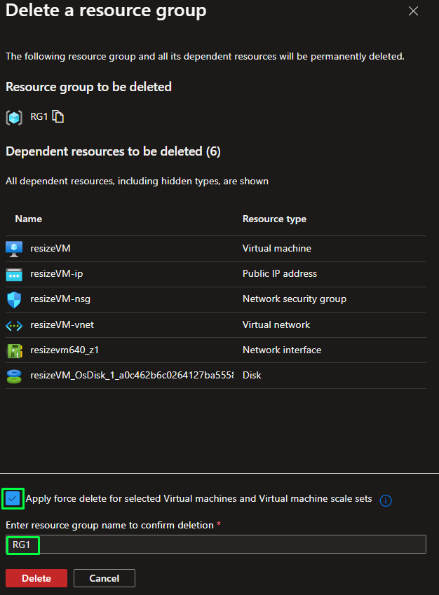

# **Completion and Conclusions**

1. You have successfully signed into Azure Portal.
2. You have successfully created a Virtual Machine.
3. You have successfully Created a tag for your resource.
4. You have successfully deleted the resources.